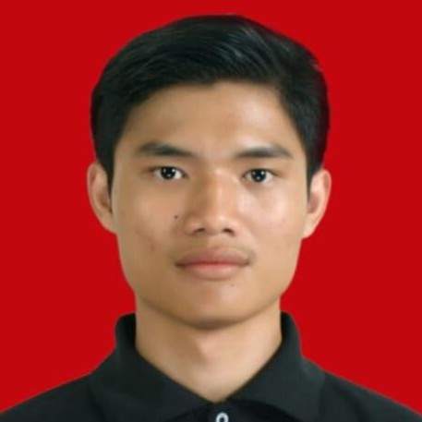NATALINO MARULITUA MANUEL BRYAN

081214303622 | [natalinomarulituamanuelbryan@gmail.com](mailto:natalinomarulituamanuelbryan@gmail.com) | https://[www.linkedin.com/in/natalino-marulitua-](http://www.linkedin.com/in/natalino-marulitua-) manuel-bryan | https://github.com/bryanotista15

A fresh graduate in Informatics Engineering from Sekolah Tinggi Manajemen Informatika dan Komputer Mardira Indonesia with relevant work experience, ready to utilize my skills and knowledge in the field of information technology to contribute to the company. I possess strong capabilities in [Programming PHP, JavaScript, Python, Wordpress, HTML, Tailwind CSS, React Native, Bootstrap, TypeScript, Figma, Canva, Capcut, Adobe Photoshop, Adobe Illustrator, Github, React.js, Web Development, OOP, Data Management, Entry Data, Cloud Computing, MySQL, Microsoft Office, Administrative]. I am a critical thinker, have a high curiosity, and am responsible in my work. Additionally, I have work experience as a Warehouse Admin, Admin, and internship experience as a Human Capital Business Partner. I am result-oriented and have a passion for continuous learning and growth in a dynamic work environment.

# Work Experiences

**PT Telkom Indonesia Tbk - Gasibu Bandung Jawa Barat** Aug 2023 - Nov 2023

*Human Capital Business Partner (Internship)*

 Conducted scanning of budget reimbursement data at the wellness unit  Ensured the safekeeping of digitalized data

 Prepared reports on budget performance outcomes

 Provided support for the development of digital learning syllabuss  Consolidated and copied data for various Telkom events

**PT Dwi Tunggal Nusantara - Mekarwangi Bandung Jawa Barat** Jan 2023 - Jun 2023

*Warehouse Administrator*

 Create receiving and delivery documents  Conduct inventory/stock opname

 Organize and arrange goods in the warehouse

 Manage inventory using warehouse management system

 Communicate with production, marketing, and logistics teams to facilitate efficient inventory management

**ID Express - Cicalengka Bandung Jawa Barat** Apr 2022 - Dec 2022

*Administrator*

 Create administrative documents

 Provide information about shipping services  Ensure administrative data accuracy

 Handle customer complaints

**JNT Express - Moh Toha Bandung Jawa Barat** Feb 2021 - Oct 2021

*Warehouse Administrator*

 Record receipt and issuance of goods and warehouse stock  Generate inventory reports and stock status

 Verify receipt and issuance of goods  Enter data into inventory system

 Manage and maintain inventory stock

# Education Level

**STMIK Mardira Indonesia - Kopo Indonesia** Aug 2020 - Sep 2024

*Bachelor of Computer, Informatics Engineering*

# Organisational Experience

**Komunitas Seni Teater - Kopo Bandung** Jan 2021 - Dec 2021

*Director*

 Interpret scripts and develop visual concepts for film, theater, or other productions  Direct actors and crew to achieve the desired creative vision

 Manage the production process, including scheduling, budgeting, and communication with the team  Edit and monitor production progress to ensure the desired final quality

**Persekutuan Mahasiswa Kristen - Kopo Bandung** Jan 2022 - Dec 2024

*Chairman and Vice Chairman*

 Lead meetings and gatherings

 Represent the organization in events and meetings  Make important and strategic decisions

 Provide advice and support to the chairperson

**Gerakan Mahasiswa Kristen Indonesia - Jatinangor Sumedang** Nov 2023 - Aug 2025

*Secretary for Information and Communication Media Function*

 Manage organization's social media (Facebook, Twitter, Instagram, etc.)

 Create and disseminate information content about organization's activities and programs  Manage organization's website and ensure accurate and up-to-date information

 Create reports on organization's activities and programs for members and the public  Assist in planning and implementing organization's communication strategy

# Skills, Achievements & Other Experience

 **Webinars Attended** (2024): Dinas Pariwisata dan Kebudayaan Provinsi Jawa Barat Data Science

 **Soft Skills**: Teamwork, Leadership, Communication, Time Management, Technological Literacy atau Tech Savviness, Planning, Organizational Skills, Multitasking, Program Management, Decision Making, Strategic Planning, Analytical Skills

 **Hard Skills**: Programming PHP, JavaScript, Python, Wordpress, HTML, Tailwind CSS, React Native, Bootstrap, TypeScript, Figma, Canva, Capcut, Adobe Photoshop, Adobe Illustrator, Github, React.js, Web Development, OOP, Data Management, Entry Data, Cloud Computing, MySQL, Microsoft Office, Administrative

 **Certification** (2024): Nomor : 5007Par.03.02/Inpar